Drawing unit test review
Name: date:

Directions: Define the following terms
- Value___________________________________________________________________

- Value scale___________________________________________________________________

- Geometric shapes ___________________________________________________________________

- Organic shapes ___________________________________________________________________

- Contour lines ___________________________________________________________________

- Still life ___________________________________________________________________

- Contrast ___________________________________________________________________

- Negative space ___________________________________________________________________

- Searching lines ___________________________________________________________________

- Shape___________________________________________________________________

- Space ___________________________________________________________________

- Form ___________________________________________________________________

- Color ___________________________________________________________________

- Line ___________________________________________________________________

- Value ___________________________________________________________________

- Texture ___________________________________________________________________

- Meditative drawing ___________________________________________________________________

- Art therapy ___________________________________________________________________

- Composition ___________________________________________________________________

Directions: answer each question in a 1-2 sentences
- Describe what a transformation is in art ________________________________________________________________________________________________________________________________________________________________________
- How do soft lines and hard lines affect the overall look of a piece
________________________________________________________________________________________________________________________________________________________________________

- How does grid drawing differ from drawing from life?

________________________________________________________________________________________________________________________________________________________________________
- What 2 main things happened in 1924 that helped bring about the art movement of Surrealism?
________________________________________________________________________________________________________________________________________________________________________
- Explain WHY each of the above helped lead to the art movement of Surrealism
________________________________________________________________________________________________________________________________________________________________________
- What makes something “surreal”?
________________________________________________________________________________________________________________________________________________________________________
- Who were 2 major artists of the Surrealist movement?
________________________________________________________________________________________________________________________________________________________________________

Directions: Use the drawing techniques we learned in this unit to complete the following tasks
- Draw a 5 point value scale from lightest to darkest using 1 of the pencil techniques we learned

What is the name of the pencil technique you chose? __________________________________
- draw an EXACT replica of the provided picture in the space next to it
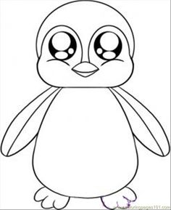

Directions: Be able to identify the principle of design that BEST describes the piece and describe why it demonstrates that principle of design.
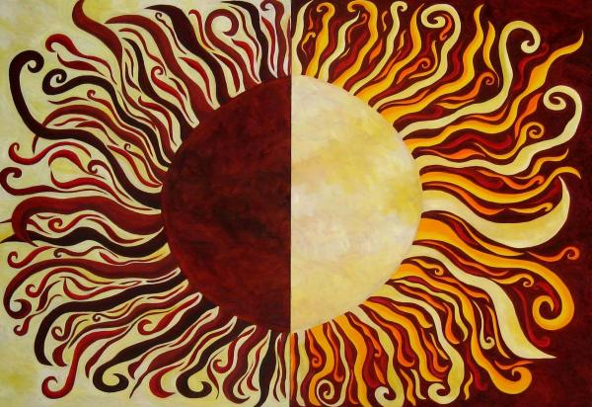

- Principle? ___________________________Why? ____________________________________________

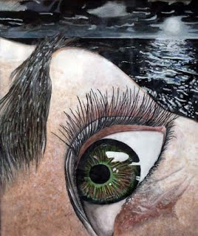

- Principle? ___________________________Why? ____________________________________________

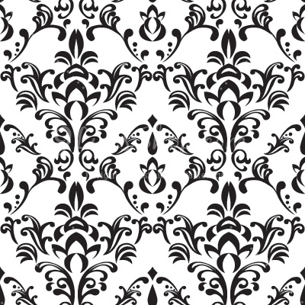

- Principle? ___________________________Why? ____________________________________________

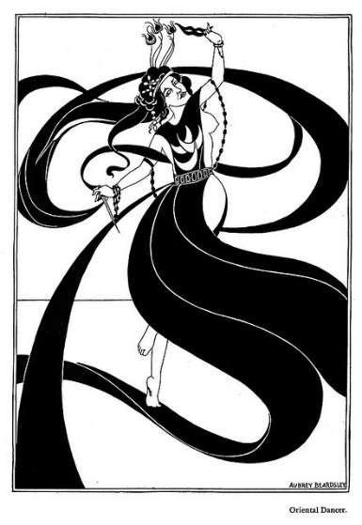

- Principle? ___________________________Why? ____________________________________________

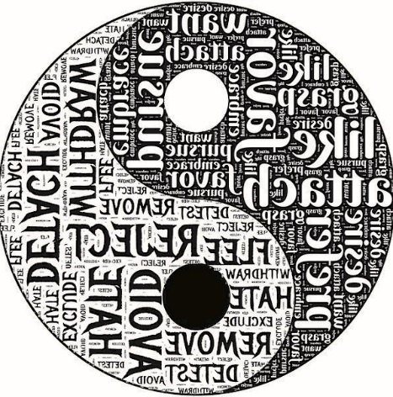

- Principle? ___________________________Why? ____________________________________________

Directions: Answer the following essay using complete sentences. Make sure to use SPECIFIC examples learned in class to defend your answer.
- Choose ONE of the essential questions for the course and write an essay explaining your answer. Use SPECIFIC examples from the class.
Essential Questions
Why do people make art?
What does art tell you about the artist?
How does art communicate cultural information?
How does learning artistic techniques help you create stronger artwork? ________________________________________________________________________________________________________________________________________________________________________________________________________________________________________________________________________________________________________________________________________________________________________________________________________________________________________________
________________________________________________________________________________________________________________________________________________________________________________________________________________________________________________________________________________________________________________________________________________________________________________________________________________________________________________
________________________________________________________________________________________________________________________________________________________________________________________________________________________________________________________________________________________________________________________________________________________________________________________________________________________________________________

