Step 1.
You can use a No. 2 pencil, but draw very lightly this shape. Make sure you leave room on your paper for the thumb, fingers, and wrist.
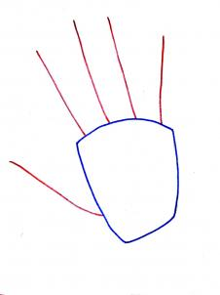

Step 2.
See how the red lines for the fingers radiate from the oblong shape placement for the back of the hand. Those do not line up strait. Notice how the tips of the lines follow the top curved line of the back. Keep this in mind while you are drawing.
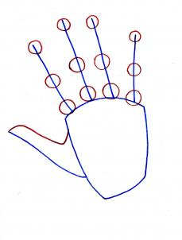

Step 3.
Now add the small circles to the lines. What is so great about those circles is they help with the finger mass and placement of the joint hinges & knuckles where the fingers bend...remember draw them on a curve (not straight). Complete this step by drawing in the upper portion of the thumb.
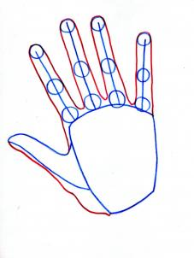

Step 4.
Congratulations! You are making great progress! Simply draw in the fingers and lower portion of the thumb.
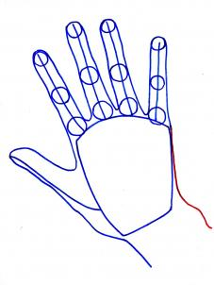

Step 5.
Make sure you extend the opposite end of the back of the hand. Remember to draw in the wrist (both the blue and red portion with the bone hump).
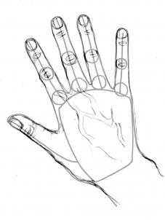

Step 6.
If you want to add nails, wrinkles at the knuckle joints, and veins on the back of the hand.
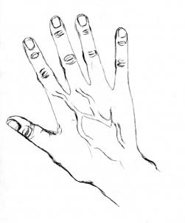

Step 7.
Fantastic! Give a sigh of relief because you have completed an outline or sketch of a realistic hand. Your picture may look like this one. If you will, please take the journey with me and dive in on a lot of tips for "How to Draw Hands." Step 15 starts with the sketching of this hand and Step 17 completes this realistic hand. BUT THERE ARE MORE TIPS that will surprise you. Let's go forward.
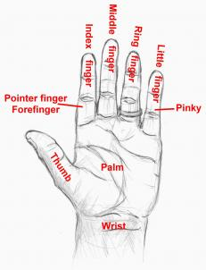

Step 8.
Okay...I don't mean to be facetious, but there were times when I was younger I used to get mixed up with the names of fingers. So for those who know and those who struggle in knowing, this is for your convenience to have at the tip of your fingers.
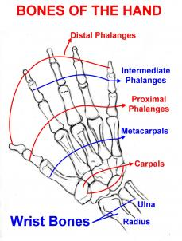

Step 9.
What is up with all this knowledge? What good is it? Well, if you have a basic knowledge of what the hand is made of, you'd draw it better. You don't need to know these by heart. It's just good to know they are there. Hey! You might recognize Carpals! Carpal Tunnel anyone? That's a disease that affects the wrist area due to repetitious work--like data entry, typing (me!), and other jobs like that. Sorry for digressing. On with the next step!
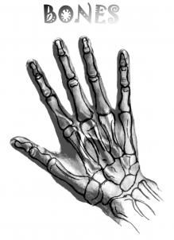

Step 10.
Here we see how the bones interact with the hand. It's like taking an x-ray!
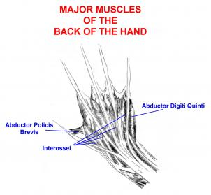

Step 11.
The hand is mostly made up of tendons and bones. However, the fingers and thumb move and flex through the control of the major muscles. Here is a view of how they look and their names.
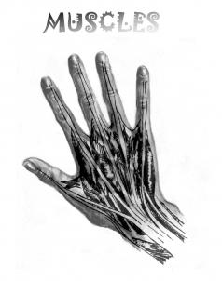

Step 12.
And we have a wonderful view of how the muscles interact with the hand.
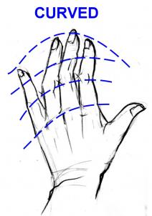

Step 13.
Curves and more curves...that is how you draw the hand. It's good to start out with some light, free guidelines that are curved. The fingernails are curved (not boxy) and the knuckles even follow a curve. This is another hand you could draw and practice with.
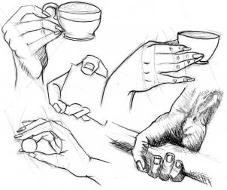

Step 14.
Observe the grasping hands I drew. You may see sketch marks and some curved lines...very few straight ones. But those helped me to place my picture and start on it with more accuracy. I first lightly drew the hands. The result was a nice sketchy mess. Then I took a dark 9B Monolith pencil to give the hands definition. I left those light curved lines to give an example of much they help. Go ahead and draw these hands. It'll help with your accuracy. The next step starts with finishing up on that hand outline you started with.
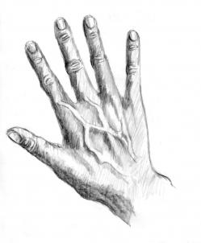

Step 15.
Take your outline and stroke in your lines. You can use the crosshatch, straight lines, or small tiny circles. Remember to start dark on the outer left sides of the thumb and fingers then proceed out lightly. The veins have the shadow on the left side... nicely draw a little darker. Leave a lighter area on the wrinkles because the top parts are closer to the light. Work with that thought as you continue to shade.
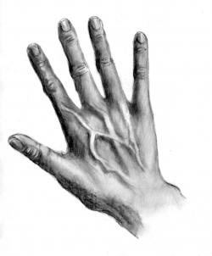

Step 16.
Now if you want some stroking, penciling, shading, tone, and highlight instructions, open up another tab or window to go to this "How to Draw Faces in Pencil." link: http://www.dragoart.com/tuts/8396/1/1/how-to-draw-faces-in-pencil,-draw-faces-with-pencil.htm Scroll down to Step 20 and look at those techniques. I did not have enough steps to put them here so I want you all to have access to help with shading, tone, and stuff like that. I've got lots of tutorials that may help in another area, check out my list here at this link: http://www.dragoart.com/tuts/all/1/46406/u.htm In this step you blend with blending stumps, tissue paper, Q-tips, etc. For highlights, you can take your eraser, but a normal No.2 eraser is messy (take a fan shaped paint brush to brush away the shavings). Or you can erase with a kneaded rubber eraser that doesn't leave any mess. I did not use any white acrylic paint to highlight.
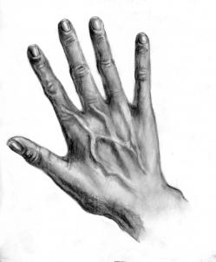

Step 17.
Here is the final product. I'm hoping you have fun with this tutorial, learning, drawing, practicing some more. What I had done was make the hand, veins more equal tone...didn't use a lot of white or highlights in this drawing. I felt it would distract from the picture. The next steps will include some more techniques, how the hand moves, and hand proportions. Stay with me because some of this info will surprise you because it surprised me.
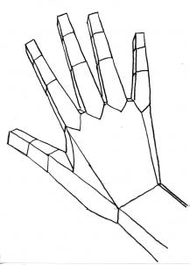

Step 18.
Using this technique of drawing the hand into planes helps you to see where the light hits and the subtle changes from shaded area to highlighted area.
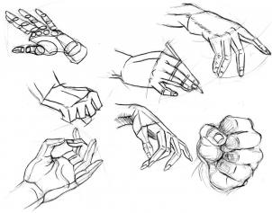

Step 19.
This is a wonderful exercise to draw the ball and block method helping to give the hand mass, believability, and accuracy. Notice my curved lines have guided me through these drawings. When you practice drawing all types of poses like these of action, you become more apt to draw hands well and bring out the personality you want for your characters.
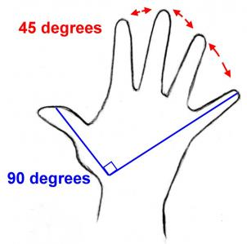

Step 20.
The fingers can stretch to a 45-degree angle. The middle finger can toggle between the index and ring finger without affecting the total distance. Isn't great to know the distance between your fully outstretched thumb and pinky is a 90-degree angle. But my thumb and pinky stretch further. I've got piano fingers. I can even do that Vulcan "Prosper & Live Long" gesture from Star Trek. I'm digressing again!
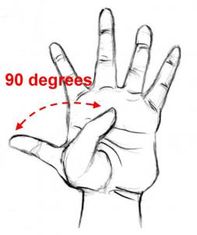

Step 21.
The thumb can flex from its outstretched position to the pinky (little finger) which is 90-degrees.
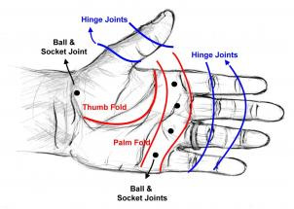

Step 22.
Here's a diagram on the hand and it's bending points. Click on the picture. I thought it was interesting where the ball joints appear. Oh, I drew this hand...you already know that. But did you know its my hand I drew? There is my hand with the ball joints and hinges where the hand folds. Those fold marks on you palm and finger are like perforated paper to help it fold.
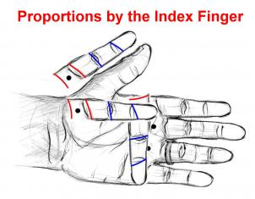

Step 23.
THIS SURPRISED ME! Take your index finger (also called pointer or forefinger) from the tip to the ball joints. Your thumb, length of palm, and width of palm should match your index finger with its ball joint. AMAZING! Check this out. Take your hand, match the bottom palm to your chin, then the top of your palm should meet near the bottom area of your eye. AMAZING! It worked for me! So this is a way you can check the proportions of your outstretched hand!
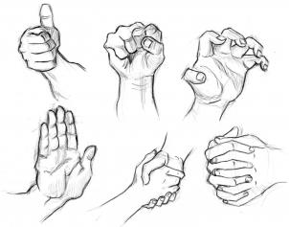

Step 24.
Here are some popular poses you can practice on. Number One or Okay. Power! Grrr! High-Five or Stop! Let's Shake! Thinking or Praying! See if these gestures mean anything else to you. Let me know. And I'd also like to know if this tutorial is helpful to you. It really boosts my day when you comment, vote and fave. If I don't get to you the same day, I will eventually answer. My peeps, I really appreciate you all for stopping by my tutorials. You all are sweethearts. I wouldn't be here without you to have fun with. LOVE & PEACE TO YOU!

